

Geometry: Concepts & Connections Syllabus
2023-2024
Instructor:
Mr. Curtis Pryor
pryorcu@boe.richmond.k12.ga.us
Rm 413

Course Description and Objectives:
Geometry: Concepts & Connections, instructional time should regularly incorporate the 8 Mathematical Practices, the Framework for Statistical Reasoning, and the Mathematical Modeling Framework through four big ideas of content: (1) numerical reasoning, (2) functional & graphical reasoning, (3) patterning and algebraic reasoning, and (4) geometric and spatial reasoning. Students will apply their algebraic and geometric reasoning skills to make sense of problems involving geometry, trigonometry, algebra, probability, and statistics. This course enhances students’ geometric, algebraic, graphical, and probabilistic reasoning skills. Students will apply their algebraic and geometric reasoning skills to make sense of problems involving geometry, trigonometry, algebra, probability, and statistics. Students will continue to enhance their analytical geometry and reasoning skills when analyzing and applying a deep understanding of polynomial expressions, proofs, constructions, rigid motions and transformations, similarity, congruence, circles, right triangle trigonometry, geometric measurement, and conditional probability.

Textbook:
HMH Into Geometry Georgia

Unit/Concept Names:
Unit 1 Polynomial Expressions Unit 7 Equations & Measurement Volume
Unit 2 Geometric Foundations, Construction, and Proof Unit 8 Probability & Statistics
Unit 3 Congruence Unit 9 Culminating Capstone Unit
Unit 4 Similarity
Unit 5 Right Triangle Trigonometry
Unit 6 Circles

Evaluation (Schoolwide Grading Policy):
- Minor Grades = 60% (quizzes, labs, and graded assignments to assess certain standards in a unit of study)
- Major Grades = 40% (unit tests, essays, research papers, project-based assignments, and culminating assessments to measure mastery of standards that comprise a unit of study)

Behavioral expectations:

Every student is responsible for helping to maintain a clean, safe learning environment. Your area must remain CLEAN at all times. The floor should be clear of trash, paper, and personal belongings. Adhere to all policies, rules, and regulations outlined in the student handbook.

  - Be Ready
A. Come prepared for class when the bell stops ringing. This means have the materials needed for class, have the “I can do it” attitude, be ready to do your best, and be ready to begin the day’s work. Materials you will need to bring to class include textbook, notebook, assignments and appropriate writing instruments (pencil). (If the student is not sitting in a desk and working on warm-up when the bell rings, THEY WILL BE MARKED TARDY!)

  - BE RESPECTFUL OF ________
- ME (THE TEACHER)
- YOUR CLASSMATES
- MY CLASSROOM

  - BE RESPONSIBLE FOR YOUR_________
- ATITUDE
- GRADE
- DEDCISIONS
- STUFF

If you choose not meet the above expectations the follow will your consequences:

- First offense -Warning- teacher and student will have a short conversation about what is expected and why.

- Second offense- parent contact- parent will be notified of the possible next steps if behavior continues

- Third offense- parent phone call and referral

Course Materials:
Pencils​
Scientific Calculator​
Composition/Spiral notebook​
Loose-leaf paper(College rule)​
Folder ​
Charged Laptop ​
​

Donations appreciated for the following (optional):
*Copy Paper * Hand Sanitizer *Dry Erase Markers *Kleenex * Disinfectant Wipes

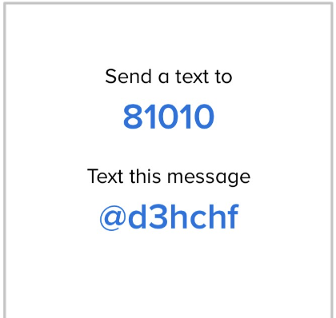
Modes of Communication:
PARENTS ONLY- (706)-426-3033
Remind messages-Students and parents
To sign up for class reminders, please visit:

---------------------------------------------------------------
Students join remind to get announcements and class updates

PLEASE SIGN AND UPLOAD TO YOUR PERIODS CANVAS PAGE ASSIGNMENT

I have read and understand all that Mr. Pryor’s Geometry syllabus contains.

Print Student’s Name:________________________________________________

Student’s Signature: _______________________________________________

Date: ______________

I have read, received, understood, and kept Mr. Pryor’s Geometry syllabus for my records.

Print Parent’s/Legal Guardian’s Name:___________________________________

Parent’s /Legal Guardian’s Signature: ___________________________________

Date: ______________

Preferred Method of contact (Please CIRCLE ALL that APPLY)
Email TEXT PHONE

Parent preferred email: __________________________________

Parent Contact Number: _______________

